**FitFlex: Your Personal Fitness Companion**

**Ideation Phase**

**Brainstorm & Idea Prioritization**

|  |  |
| --- | --- |
| Date | 11 March 2025 |
| Team ID | SWTID1741257108149874 |
| Project Name | Fitflex |
| Maximum Marks | 4 Marks |

**Step-1: Team Gathering, Collaboration and Select the Problem Statement**

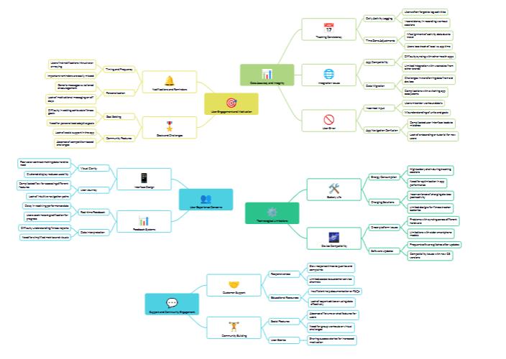

**Step-2: Brainstorm, Idea Listing and Grouping**

